Programming Languages Research Report

Course: CST 8002-040 Programming Languages Research Proj.
Assignment: Practical Project 03
Instructor: Tyler DeLay
Student Name: Qinyu Luo
Student ID: 041137796
Due Date: 11/16
Submitted: 11/16

Evidence of Learning
This section demonstrates the implementation of Inheritance and Polymorphism as the advanced programming feature for Practical Project Part 3.

1. Inheritance
The project implements a class hierarchy where Record serves as the base class, and JSONFormatRecord and TableFormatRecord extend it as subclasses.

Base Class: Record.js
Lines 1-30: The Record class is defined as the parent class with core data fields and a formatOutput() method that can be overridden by subclasses.
class Record {
constructor(identification, year, transect, quadrat, name, count) {
this.identification = identification;
this.year = year;
// ... other fields
}
formatOutput() {
// Base implementation - can be overridden
return `ID: ${this.identification} | Year: ${this.year} | ...`;
}
}

Subclass 1: JSONFormatRecord.js
Lines 1-28: JSONFormatRecord extends Record and overrides the formatOutput() method to return JSON formatted output.
import Record from './Record.js';
class JSONFormatRecord extends Record {
formatOutput() {
// Override to return JSON format
return JSON.stringify({
identification: this.identification,
year: this.year,
// ... all fields
}, null, 2);
}
}

Subclass 2: TableFormatRecord.js
Lines 1-35: TableFormatRecord extends Record and overrides the formatOutput() method to return table-formatted output with aligned columns.
import Record from './Record.js';
class TableFormatRecord extends Record {
formatOutput() {
// Override to return table format
return `| ${this.identification.padEnd(15)} | ${this.year} | ...`;
}
static getTableHeader() {
return `| Identification | Year | ...`;
}
}

2. Polymorphism
Polymorphism is demonstrated in UserInterface.js where an array of base class type (Record) stores instances of different subclasses, and the formatOutput() method is called polymorphically.

UserInterface.js
Lines 115-165: The displayRecordsWithFormat() method creates an array of Record type containing different subclass instances, then calls formatOutput() on each.
displayRecordsWithFormat(formatType) {
// Convert records to appropriate subclass
const formattedRecords = records.map(record => {
if (formatType === 'json') {
return new JSONFormatRecord(...); // Subclass 1
} else if (formatType === 'table') {
return new TableFormatRecord(...); // Subclass 2
}
return record; // Base class
});
// POLYMORPHIC CALL: Each object uses its own formatOutput()
formattedRecords.forEach(record => {
console.log(record.formatOutput()); // Different output!
});
}
Key Point: The same method call (formatOutput()) produces different results depending on the actual object type at runtime - this is polymorphism in action.

Program Changes

Architecture Overview
The program maintains the layered architecture from Project 2 with the following structure:
• Model Layer: Contains Record (base class), JSONFormatRecord, and TableFormatRecord
• Business Layer: DataManager handles CRUD operations
• Presentation Layer: UserInterface handles user interactions and polymorphic displays
• Persistence Layer: FileHandler manages file I/O operations

Location of Advanced Feature
The inheritance and polymorphism implementation is primarily located in the Model layer:
1. model/Record.js - Base class definition
2. model/JSONFormatRecord.js - First subclass (JSON format)
3. model/TableFormatRecord.js - Second subclass (Table format)
4. presentation/UserInterface.js - Polymorphic method calls (lines 115-165)

Benefits of Layered Architecture
The layered architecture facilitated the addition of polymorphic formatting in several ways:
1. Separation of Concerns: Adding new Record subclasses in the Model layer did not require changes to the Business or Persistence layers, demonstrating good separation of concerns.
2. Easy Refactoring: The existing Record class was easily refactored to become a base class without breaking existing functionality, as all layers interact through well-defined interfaces.
3. Testability: The polymorphic formatting can be tested independently in the Model layer without needing to run the entire application, making unit testing straightforward.
4. Extensibility: New output formats can be added by simply creating new subclasses of Record without modifying existing code in other layers (Open/Closed Principle).

Program Demonstration via Screen Shots
NOTE: Replace the placeholder text below with actual screenshots from your running program. Make sure your full name (Qinyu Luo) appears in all screenshots.

Screenshot 1: Main Menu
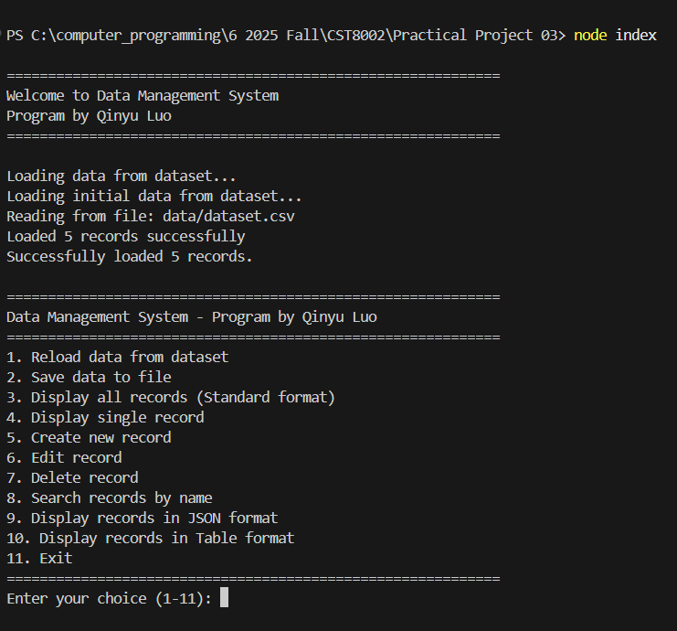
Description: The main menu now includes two new options (9 and 10) for displaying records in JSON and Table formats, demonstrating the polymorphic formatting feature.

Screenshot 2: Standard Format Display
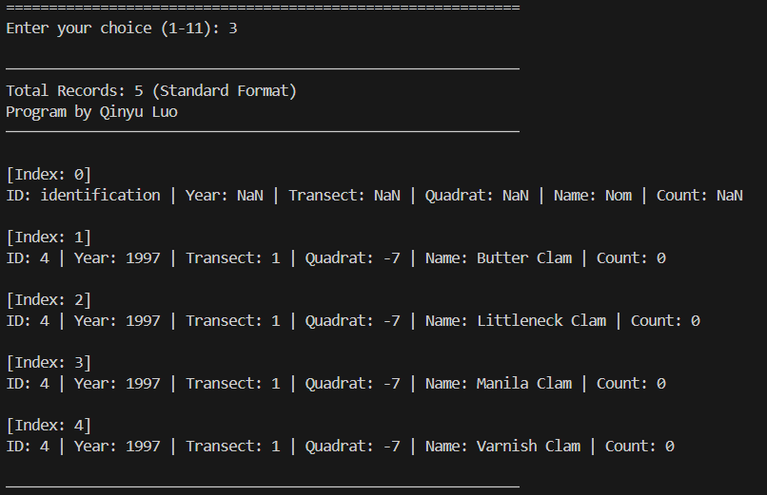
Description: Records displayed using the base Record class formatOutput() method, showing the standard one-line format. Program by Qinyu Luo appears in the output.

Screenshot 3: JSON Format Display
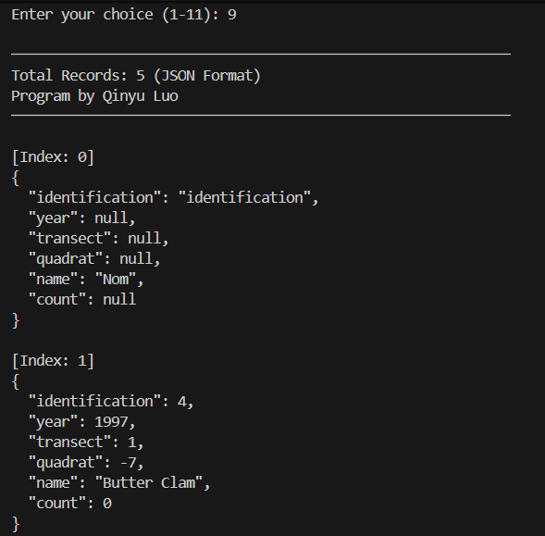
Description: Records displayed using JSONFormatRecord subclass, demonstrating polymorphism. The same data is now formatted as JSON objects with proper indentation.

Screenshot 4: Table Format Display
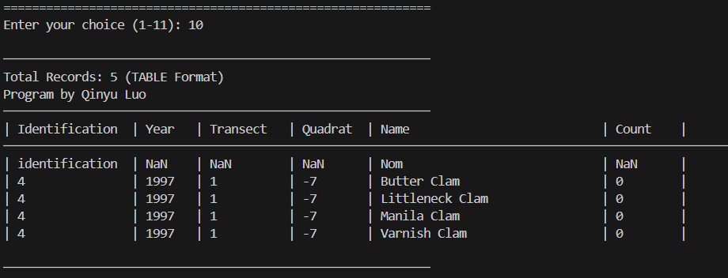
Description: Records displayed using TableFormatRecord subclass with aligned columns. This demonstrates how different subclasses override formatOutput() to produce different outputs.

Screenshot 5: All CRUD Operations Working
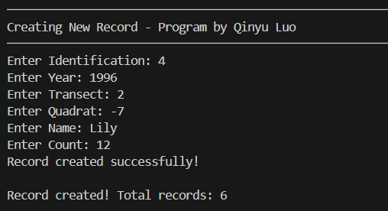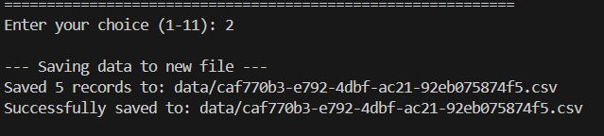
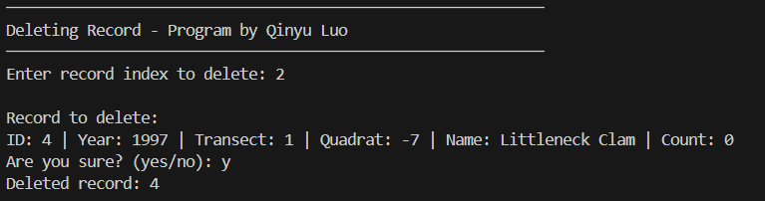
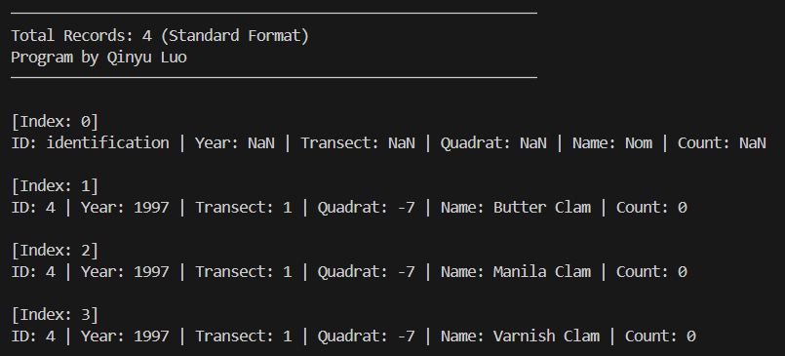
Description: Demonstrates that all functionality from Project 2 remains intact, including create, read, update, and delete operations.

Unit Testing Demonstration via Screen Shots
NOTE: Replace the placeholder text below with actual screenshots of your test results. Run the command: node tests/PolymorphicFormat.test.js

Screenshot 1: Test Suite Execution
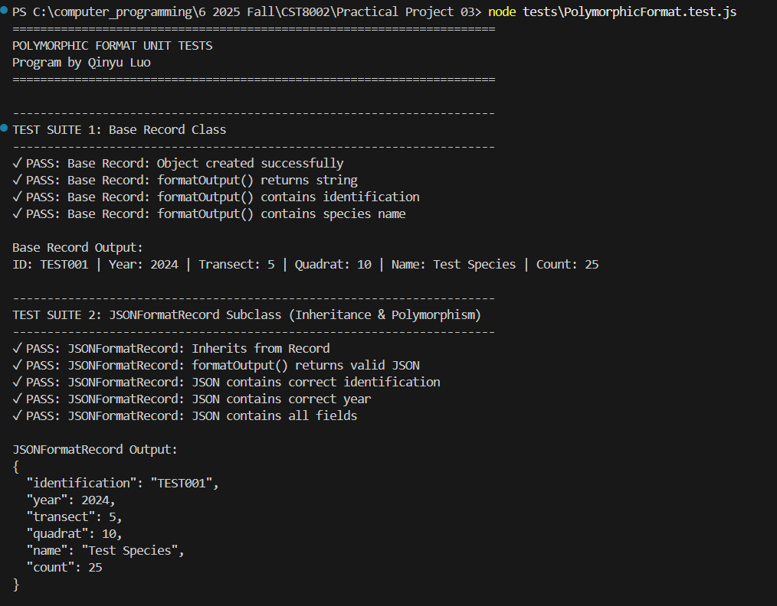
Description: The unit test file tests all aspects of the polymorphic implementation, including inheritance verification, format output correctness, and polymorphic method calls. Shows "Program by Qinyu Luo" in the output.

Screenshot 2: Test Results Summary
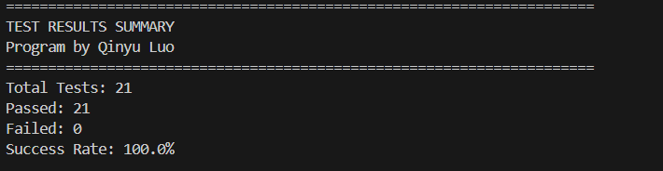
Description: Summary showing all tests passed, confirming that the inheritance and polymorphism implementation is correct. The tests verify that each subclass properly overrides formatOutput() and produces the expected format.

Screenshot 3: Polymorphic Output Examples
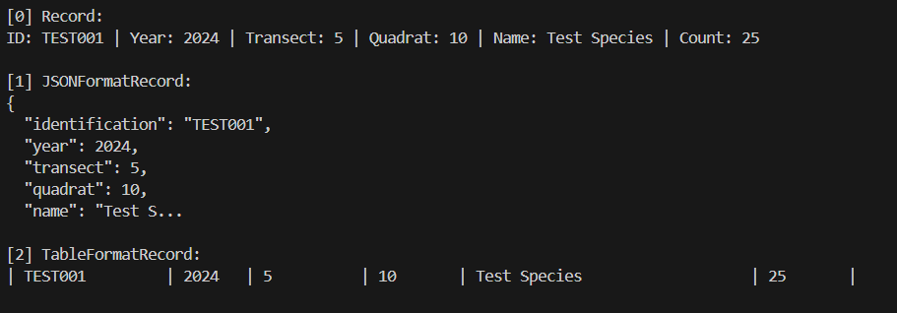
Description: Test output showing the same record data formatted three different ways (standard, JSON, and table), demonstrating polymorphism in action.

Additional Information

GitHub Repository
Branch: project3
Tag: V3.0
Link: https://github.com/Nanastrike/CST8002_PracticalProject_040_LuoQinyu/tree/project3/Practical%20Project%2002

Files Modified/Created for Project 3
• model/Record.js (refactored as base class)
• model/JSONFormatRecord.js (new subclass)
• model/TableFormatRecord.js (new subclass)
• presentation/UserInterface.js (updated with polymorphic displays)
• tests/PolymorphicFormat.test.js (new unit test file)

Commit History
1. Refactored Record class as base class with formatOutput method
2. Created JSONFormatRecord subclass with JSON output format
3. Created TableFormatRecord subclass with table output format
4. Modified UserInterface to use polymorphic formatOutput method calls
5. Added unit tests for polymorphic record formatting
6. Added JSDoc documentation comments to all classes
7. Tagged V3.0 for Project 3 submission

